Customization – Master Data Maintain
- FICO Setting
- Material Master

Customer account groups in SAP are used to classify customers into business partner functions that fit best the nature of the business transaction. Customer account groups control the customer hierarchy containing the customer master record. It determines the role of a customer and customer master data.
When a customer account is created, it is assigned to a certain account group.
There are different customer account groups in SAP, the following 4 are used more often and they are major customer account groups used in sales:
- 0001 - Sold-to Party
- 0002 - Ship-to Party or Goods Recipient
- 0003 - Payer
- 0004 - Bill-to Party
The fiscal year is a time period used to prepare the financial statements in organizations. Based on the business needs some organizations have fiscal years which start from Jan to Dec and some Apr to Mar etc. Fiscal year can be further divided into shorter time frames which can be months which are referred to as periods.
SAP allows a maximum of 16 posting periods in each fiscal year. It consists of 12 regular posting periods and 4 special periods which can be used for audit or tax adjustments to already closed periods. One fiscal year variant can be assigned to multiple company codes.
Financial Accounting
1 | To make Customer Account Group | OBD2 | Spro - > SAP IMG - > Financial Accounting -> Accounts Receivable and Accounts Payable -> Customer Accounts -> Master Data -> Preparation for Creating Master -> Define Account Groups with Screen Layout/Customers
2 | To assign Customer Account Group to Sales Area | XD01 | Spro - > SAP IMG - > Financial Accounting -> Accounts Receivable and Accounts Payable -> Customer Accounts -> Master Data -> Preparation for Creating Master -> Define Account Groups with Screen Layout/Customers
3 | To assign number Range Category to Customers | OVZA/VN01 | Spro - > SAP IMG - > Financial Accounting -> Accounts Receivable and Accounts Payable -> Customer Accounts -> Master Data -> Preparation for Creating Master -> Assign Number Ranges to Customer Account Group
4 | Maintain Fiscal Year Variant | OB29 | Financial Accounting >> Financial Accounting Global settings >> Fiscal Year >> maintain Fiscal year variant
5 | Assign Company Code to a Fiscal Year Variant | OB37 | Financial Accounting >> Financial Accounting Global settings >> Fiscal Year >> Assign Company Code to Fiscal Year Variant

Logistic-General -> Material Master
The material types that you use are configured in Customizing for the Material Master under
Logistics Master Data : Material Master -> Material -> Control data -> Define material type attributes.
The following list shows you the material types contained, for example, in the standard SAP R/3 System, and what their different roles are:
DIEN (services)
Services are procured externally and cannot be stored. A material master record of this material type can always contain purchasing data.
FERT (finished products)
Finished products are produced by the company itself. Since they cannot be ordered by Purchasing, a material master record of this material type does not contain purchasing data.
FHMI (production resources/tools)
Production resources/tools are procured externally and used in the manufacture of products. A material master record of this material type can contain purchasing data, but no sales data. It is managed on a quantity basis. Examples of production resources/tools are apparatus, equipment, and measuring and testing devices.
HALB (semifinished products)
Semifinished products can be procured externally (sub-contracting) as well as manufactured in-house. They are then processed by the company. A material master record of this material type can contain both purchasing and work scheduling data.
HAWA (trading goods)
Trading goods are always procured externally and then sold. A material master record of this material type can contain purchasing and sales data.
HIBE (operating supplies)
Operating supplies are procured externally and required for the manufacture of other products. A material master record of this material type can contain purchasing data but no sales data.
NLAG (non-stock material)
Non-stock material is material that is not held in stock because it is consumed immediately. (Office supplies such as stationary. You need to create purchase order and accounting document for payment but the stock balance is always zero as it is issued out immediately to the various department.)
ROH (raw materials)
Raw materials are always procured externally and then processed. Since raw materials cannot be sold, a material master record of this material type contains no sales data.
UNBW (non-valuated materials)
Non-valuated materials are managed on a quantity basis, but not by value.
VERP (packaging materials)
Packaging materials are used to transport goods and come with the goods free of charge. A material master record of this material type is managed both on a quantity basis and by value.
WETT (competitive products)
Competitive products have their own material master records created from the Basic Data view. The competitor's number, which is stored in the material master record, assigns the material to a particular competitor.

1 | Maintain company code for material management | OMSY | SPRO > Logistics – General > Material Master > Basic settings > Maintain company code for material management.
2 | Maintain Material Type | OMS2 | SPRO > Logistics – General > Material Master > Basic Settings > Material Types > Define Attributes of material types
 | MRP TYPE – ND – No Planning
3 | Change Material Type  (If required) | MMAM | SAP Menu->Logistics -> Material Management -> Material Master -> Material -> Change Material Type.
4 | Update quantity and value for  Material type and valuation area ( your plant) | OMS2
5 | To Make Material | MM01 | SAP Menu -> Logistics -> Materials Management - > Material Master -> Create (General) -> MM01 (Immediately)
 | Maintain Plant Parameters |  | SPRO>Materials Management>Inventory Management and Physical Inventory>Plant Parameters.
6 | Create Material Stock | MB1C  MIGO
7 | Material Stock Overview | MMBE
8 | Customer Material info record | VD51

https://www.tutorialscampus.com/sap-sd/create-customer-material-info-record.htm

Views ( Basic data1, Basic Data2, Sales Org1, Sales Org2, MRP1, MRP2, MRP3, MRP4)
The 4 MRP views that we maintain has got its individual importance like in
- MRP1 - For consumption based planning
- MRP2 - Procurement type (inhouse or external)
- MRP3 - For Planning strategy & consumption period
- MRP4 - For repetitive mfg.
It is not mandatory to maintain all MRP views. It depends upon your company profile.

- Ensure Entry of purchasing group .
In OMSY steps, u have to enter .....
Company Code .....
Company Name ..............
Fiscal Year of Current Period 2008
Current period (posting period) X
Fiscal year of previous period 2008( will come automatic)
Month of previous period( X-1)( will come automatic)
Fiscal year of last period of previous year 2007
Last month of previous year 12
Allow Posting to Previous Period (Back posting)
Disallow back posting after a change of period
- Inventory Management and Physical Inventory
  - Plant Parameters

MB1C: How to Create Material Stock in SAP

Background
Their are more then one Tcode for create Material Stock .
- MB1C ( Other Goods Receipts) for opening balance creation of material.
- MIGO (used for Issue / Transfer / Receipt of material).
We use here MB1C Tcode to Create Material Stock as opening balance.
Step-1.
- Enter Tcode MB1C in command field.
- Enter Movement Type 561 , Plant & Storage location.
click Enter Button.
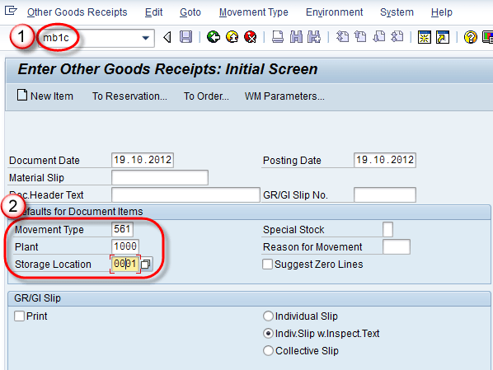
Step-2
24.1M
165
What is JVM (Java Virtual Machine) with Architecture JAVA Programming Tutorial
After enter on above screen ,item screen as below appear-
- Enter Material code for which we need to create stock.
- Enter Quantity of material for stock creation.
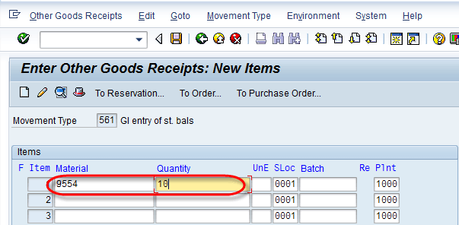
Step-3
click on save button .
A message "Document 5000021944 posted" displayed.

MMBE – Check Stock Position.
8-Jul-21
Define Chart of Accounts for company code
- OMRG
- OB62
Material PLASTIC BOTTLE does not exist in warehouse S4T
- Donot start ware hourse
Account determination for entry INT BSX ____ ___ VC01 not possible
Message No. M8147
- OBYC
Account determination for entry INT GBB 0001 BSA VC01 not possible

G/L account 300000 does not exist in company code SATE
- FS00
No corporate chart of accounts is defined for chart of accounts INT

